Project Development - Database design

## Task:

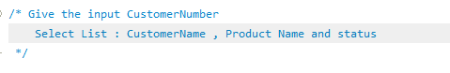

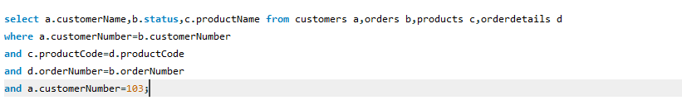

## Task:



